ECON0004 TUTORIAL 2
Please note that this assignment should be submitted using the relevant Turnitin link on Moodle. The deadline for submission is 11:59pm on Friday, 30 January, 2026.

- Answer questions 1-4 in Part 1.1 The behaviour of average surface temperature over time of empirical project 1 “Measuring Climate Change” (working in Python) in the e-book “Doing Economics: Empirical projects”.
Please follow the walk-through in the e-book. However, please note the following:
  - The most recent data available is 2025, which is different from the version used in the e‑book when it was last updated.
  - Please choose a month different from the example demonstrated in the e‑book.
  - To simplify the process, I will demonstrate how to download the dataset and load it into Python during the practical lecture on Tuesday. For now, please begin with Question 2, and then return to Question 1 after the practical session.

Answer for 1.
1) Temperature anomalies mean subtracting the observed temperature to the normal temperature that is calculated as average of 30 years in the specific place and time. Hence using temperature anomalies is a much more accurate measure to observe the changes as it accounts for variations in temperature that are caused due to location and season.
2)
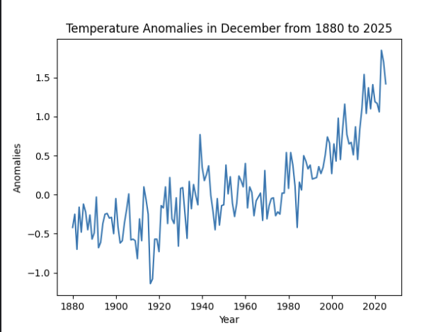
Figure 1

- You are interested in the effect of training courses on wages. You start with regressing ln wages on the number of weeks individual i has been in training in the last 5 years.
Dependent variable |  | ln wages
 | (1) | (2) | (3)
 | Coeff | Coeff | Coeff
Constant | 3.825 | 3.242 | 3.582
# Weeks of training | 0.0015 | - | 0.0009
Education | - | 0.102 | 0.082

  - In model (1), interpret the coefficient on the number of weeks of training courses. How much are wages predicted to increase if a worker spent 36 additional weeks in training course over the past 5 years?
  - You are worried that the estimate for the number of weeks in training on wages may be biased due to omitted variables, most importantly education. How does omitting education from regression (1) affect the estimate on weeks in training if education and weeks in training are positively correlated? What if education and training are negatively correlated? Which scenario do you consider more likely?
  - By comparing specifications (1) and (3), and (2) and (3), deduce the nature of the correlation between training and education in this sample. Explain your answer.
1

